**COLLEGE CODE: 1133**

**COLLEGE NAME: VELAMMAL INSTITUTE OF TECHNOLOGY**

**DEPARTMENT: AI&DS**

**STUDENT NM-ID: aut113323aib17**

**ROLL NO: 113323243105**

**DATE: 04-05-2025**

**TECHNOLOGY-PROJECT NAME: COST ESTIMATION AND BUDGET ANALYSIS**

**SUBMITTED BY,**

**1.JANANI.J,**

**2.SRIMATHI.T,**

**3.TINCKY PRIYA.J**

**Title: Smart Cost Estimation and Budget Analysis System**

**Abstract:**

The Smart Cost Estimation and Budget Analysis project aims to transform financial planning by applying intelligent algorithms to accurately forecast costs and analyze budgets. This system integrates historical data modeling, real-time expense tracking, and report generation to aid decision-makers in achieving financial efficiency. This final documentation details the system’s development, performance, and demonstration. Features such as dynamic cost prediction, variance analysis, risk management, and integration with ERP/Accounting tools are also highlighted. Supporting visuals like workflow diagrams, interface snapshots, and code snippets will provide a complete understanding of the system architecture.

**1. Project Demonstration**

**Overview:**

The demonstration showcases the system’s ability to analyze financial data, generate cost projections, and recommend budget optimizations. Key focus areas include real-time tracking, predictive analysis, and financial report generation.

**Demonstration Details:**

**System Walkthrough:** Real-time demonstration from data input to cost prediction output, showing user interaction with the system’s dashboard.

**Dynamic Estimation:** Presentation of the algorithm’s response to various budget scenarios and real-time cost recalculations.

**Data Integration:** Illustration of how the system fetches data from external sources such as spreadsheets or ERP systems.

**Performance Metrics:** Highlights include processing speed, accuracy of projections, and ability to handle large datasets.

**Security & Compliance:** Demonstration of user data protection measures, including encryption and financial compliance standards.

**Outcome:**

Stakeholders will gain confidence in the system’s capabilities to provide accurate and scalable financial insights in real-world applications.

**2. Project Documentation**

**Overview:**

This section includes all supporting documents, from system architecture to user manuals and performance reports.

**Documentation Sections:**

**System Architecture:** Diagrams showing cost estimation modules, reporting flows, and data pipelines.

**Code Documentation:** Explanation of major modules like cost forecasting models, budgeting logic, and input validation.

**User Guide:** Step-by-step instructions for finance teams to use the dashboard, import data, and review financial reports.

**Administrator Guide:** Covers system setup, maintenance, error handling, and performance tuning.

**Testing Reports:** Results from unit testing, performance testing under different financial scenarios, and error handling accuracy.

**3. Feedback and Final Adjustments**

**Overview:**

User and stakeholder feedback is collected after the demonstration for further improvements.

Steps:

**Feedback Collection:** Responses via surveys and live testing sessions with stakeholders.

**Refinement:** Enhancements based on issues like inaccurate forecasts or UI/UX inconsistencies.

**Final Testing:** A complete system test post-adjustments to validate readiness for deployment.

**Outcome:**

Final version of the tool is optimized for business use, with improved usability and reliable forecasting output.

**4. Final Project Report Submission**

**Overview:**

The final report captures all aspects of the project, including methodology, testing, results, and lessons learned.

**Report Sections:**

**Executive Summary:** Key goals, achievements, and financial impact.

**Phase Breakdown:** Overview of each project phase, including system design, data modeling, and integration.

**Challenges & Solutions:** Discussion of major challenges like inconsistent data, estimation errors, and system lag.

**Outcomes:**

Description of the final system, user adoption feedback, and performance highlights. Outcome:

A detailed, professional project report ready for evaluation and future reference.

**5. Project Handover and Future Works**

**Overview:**

Recommendations for future system improvements and scalability.

**Handover Details:**

Next Steps: Suggestions include integration with AI-based market analysis, support for multi-currency budgeting, and mobile platform expansion.

**Outcome:**

Project handover is formalized with all necessary documentation and roadmap for future enhancements.

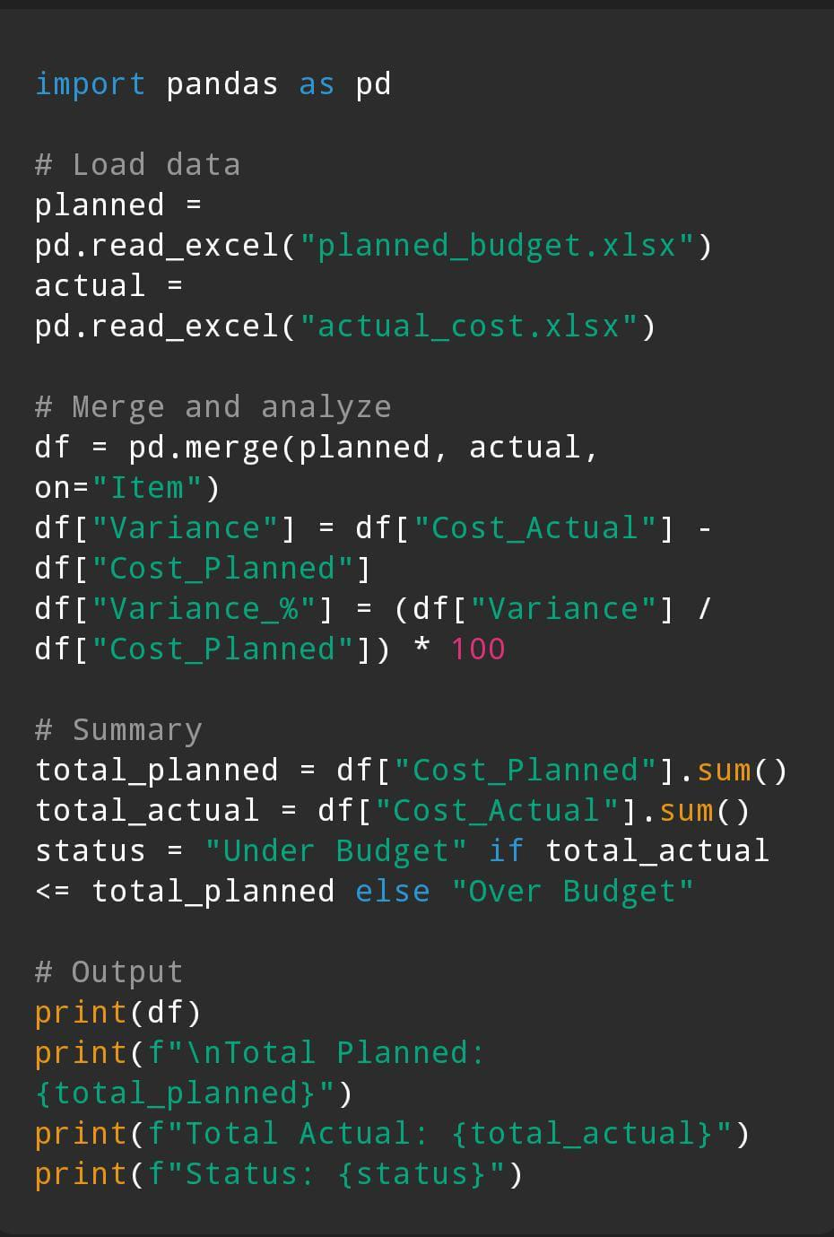

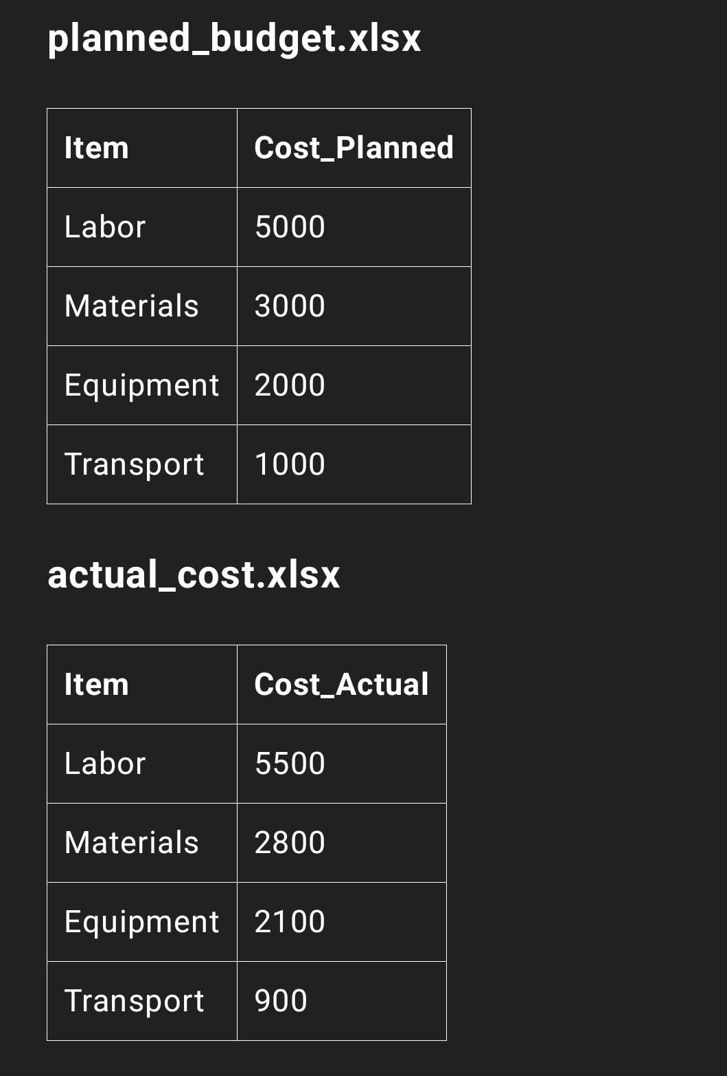

**Outcomes**